Procedures to Obtain Permits for Barricading, Excavating and/or Construction in Public Right-of-way

As required by City Ordinance, anyone working within City right-of-way is required to obtain a permit. The documents below must be on file in our system prior to submitting an application:

- Contractor must present evidence of at least $2,000,000 in general liability insurance coverage, by providing the original of a Certificate of Insurance, which shows the certificate holder as follows:
City of Albuquerque
Department of Municipal Development Construction Coordination Section
PO BOX 1293
Albuquerque, NM, 87103
- To perform excavation work, Contractor must have and provide a copy of a State License GF-09, GF-98, MM-98, EL-01, or EE-98.
- To perform concrete work, contractor must have and provide a copy of a State License GA-01, GA-02, GA-03, or GA-98.
- If excavating any part of the right-of-way, contractor must post and provide the original of a $10,000 Contractor’s Excavation Bond using the City’s approved form.
- If performing concrete work, must post and provide the original of an additional
$5,000 Contractor’s Sidewalk, Curb, and Gutter Bond using the City’s approved form.
- If performing a water tap, must provide a water tapping bond associated with the activity in question.

All documents may be emailed to dmdccs@cabq.gov, or sent to our office.

CONTRACTOR’S EXCAVATION BOND

BOND NO.

KNOW ALL MEN BY THESE PRESENTS:

THAT , as Principal, hereinafter called the Principal, and _, a corporation duly organized and existing under and by virtue of the laws, of the State of and authorized to do business in the State of New Mexico, as Surety, hereinafter called the Surety, are held and firmly bound unto the City of Albuquerque, New Mexico, as Obligee, hereinafter called the City, in the sum of TEN THOUSAND DOLLARS ($10,000) for the payment of which sum well and truly to be made, we bind ourselves, our heirs, executors, administrators, successors and assigns, jointly and severally, firmly by these presents.

WHEREAS, the Principal is excavating or is about to commence excavating of a public place within the City of Albuquerque; and

WHEREAS, the City's Street Excavation & Barricading Ordinance, 6-5-2-3 (A)(2), (R.O. 2005) requires the Principal to furnish such a bond.

NOW, THEREFORE, the condition of this obligation is such that, if the said Principal shall excavate and restore the public place in such a way as to comply with all requirements of the City's Street Excavation & Barricading Ordinance, and shall make payment to the City of all costs incurred by the City in performing work for the Principal and shall indemnify and save harmless the City against all incomplete or defective materials and workmanship for a period of one (1) year from the date the work is accepted by the City, then this obligation to be null and void; otherwise to remain in full force and effect.

SIGNED AND SEALED this day of _, 20 _.

ATTEST:

Principal

By:

Title:

ATTEST:

Surety

By:

Title:

(Attach Power of Attorney)
ACKNOWLEDGEMENTS
For an Attorney-in-Fact of a Surety

STATE OF COUNTY OF
)
) SS
)

This instrument was acknowledged before me this day of , 20

by
(Name of Person) as attorney-in-fact on behalf of

(Name of Surety).

My Commission Expires:
Notary Public

For a natural person acting in his own right

STATE OF COUNTY OF
)
) SS
)

This instrument was acknowledged before me this
(Name of Person).
day of , 20 by

My Commission Expires:
Notary Public

For a partnership acting by one or more partners

STATE OF COUNTY OF
)
) SS
)

This instrument was acknowledged before me this
day of , 20 by

(Name of Partner) on behalf of
(Name of Partnership).

My Commission Expires:
Notary Public

For a corporation or incorporated association

STATE OF COUNTY OF
)
) SS
)

This instrument was acknowledged before me this
day of , 20 by

, (Name of Officer) (Title of Officer) of
(Name of Corporation), a
(State or County of Incorporation) corporation, on behalf of the corporation.

My Commission Expires:
Notary Public

CONTRACTOR’S SIDEWALK, DRIVE-PAD, CURB & GUTTER BOND

KNOW ALL MEN BY THESE PRESENTS:

BOND NO.

THAT , as Principal, hereinafter called the Principal, and , a corporation duly organized and existing under and by virtue of the laws of the State of and authorized to do business in the State of New Mexico, as Surety, hereinafter called the Surety, are held and firmly bound unto the City of Albuquerque, New Mexico, as Obligee, hereinafter called the City, in the sum of FIVE THOUSAND DOLLARS ($5,000) for the payment of which sum well and truly to be made, we bind ourselves, our heirs, executors, administrators, successors and assigns, jointly and severally, firmly by these presents.

WHEREAS, the Principal is building, constructing or is about to commence the building and construction of a concrete sidewalk, drive-pad, and/or curb and gutter within the City of Albuquerque; and

WHEREAS, the City's Sidewalk Ordinance, 6-5-5-8 et seq, (R.O. 1994), requires the Principal to furnish such a bond.

NOW THEREFORE, the condition of this obligation is such that, if the said Principal shall build and construct all sidewalks, drive-pads, and/or curbs and gutters in such a way as to comply with all requirements of the City's Sidewalk Ordinance, and shall indemnify and save harmless the City against all defects in or improper construction of any sidewalks, drive-pads, and/or curbs and gutters so built or constructed for one (1) year from the date of completion thereof, then this obligation to be null and void; otherwise to remain in full force and effect.

SIGNED AND SEALED this day of , 20 .

ATTEST:

Principal

By:

Title:

ATTEST:

Surety

By:

Title:

(Attach Power of Attorney)

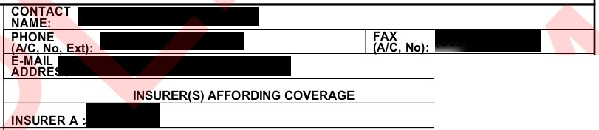

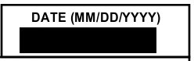
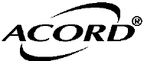
THIS CERTIFICATE IS ISSUED AS A MATTER OF INFORMATION ONLY AND CONFERS NO RIGHTS UPON THE CERTIFICATE HOLDER. THIS CERTIFICATE DOES NOT AFFIRMATIVELY OR NEGATIVELY AMEND, EXTEND OR ALTER THE COVERAGE AFFORDED BY THE POLICIES BELOW. THIS CERTIFICATE OF INSURANCE DOES NOT CONSTITUTE A CONTRA CT BETWEEN THE ISSUING INSURER(S), AUTHORIZED REPRESENTATIVE OR PRODUCER,AND THE CERTIFICATE HOLDER.
NAIC #
INSURER C :
INSUR ER D :
INSURER E :
INSURER F :
CERTIFICATE OF LIABILITY INSURANCE
IMPORTANT : If the certificate holder is an ADDITIONAL INSURED, the policy(ies) must be endorsed. If SUBROGATION IS WAIVED, subject to
the terms and conditions of the policy,certain policies may require an endorsement. A statement on this certificate does not confer rights to the certificate holder in lieu of such endorsement(s).
PRODUCER
INSURER B :
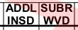
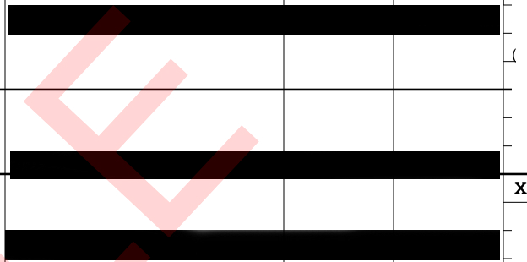
COVERAGES CERTIFICATE NUMBER: S-16 Rewrite REVISION NUMBER:
THIS IS TO CERTIFY THAT THE POLICIES OF INSURANC E LISTED BELOW HAVE BEEN ISSUED TO THE INSURED NAMED ABOVE FOR THE POLICY PERIOD INDICATED. NOTWITHSTANDING ANY REQUIREMENT, TERM OR CONDITION OF ANY CONTRACT OR OTHER DOCUMENT WITH RESPECT TO WHICH THIS CERTIFICATE MAY BE ISSUED OR MAY PERTAIN, THE INSURANCE AFFORDED BY THE POLICIES DESCRIBED HEREIN IS SUBJECT TO ALL THE TERMS , EXCLUSIONS AND CONDITIONS OF SUCH POLICIES. LIMITS SHOWN MAY HAVE BEEN REDUCED BY PAID CLAIMS.

INSR
LTR TYPE OF INSURANCE
X COMMERCIAL GENERAL LIABILITY
A CLAIMS-MADE W OCCUR

GEN'L AGGREGATE LIMIT APPLIES PER:
POLICY EFF POLICY EXP
POLICY NUMBER MM/DD/YYYY MM/DD/YYYY
LIMITS
EACH OCCURRENCE $ 1,000 ,000
$ 250 ,000
$ 10 ,000
PERSONAL & ADV INJURY $ 1,000 ,000
GENERAL AGGREGATE $ 3,000 ,000

x POLICY DPRO- DLOC OTHER:
JECT
AUTOMOBILE LIABILITY

A ANY AUTO
x
ALL OWNED SCHEDULED
AUTOS AUTOS
NON-OWNED
HIRED AUTOS AUTOS

UMBRELLA LIAS OCCUR
A x EXCESS LIAS CLAIMS-MADE OED RETENTION$
WORKERS COMPENSATION
PRODUCTS - COMP/OP AGG $ 3 ,000 ,000
CYBRL $ 50 ,000
COMBINED SINGLE LIMIT
$ 1,000 ,000
Ea accident
BODILY INJURY (Per person) $
BODILY INJURY (Per accident ) $ PROPERTY DAMAGE
$
Per accident
Uninsured motorist Bls lit limit $ 1,000 ,000
EACH OCCURRENCE $ 2 000 000
AGGREGATE $ 2 000 000
$
OTH-

AND EMPLOYERS' LIABILITY
ANY PROPRIETOR/PARTNER /EXECUTIVE OFFICER/MEMBER EXCLUDED?
A (Mandatory in NH)
If yes, describe under
DESCRIPTION OF OPERATIONS below
Y / N
O N / A
ER
E.L. EACH ACCIDENT $ 1 000 000
E.L. DISEASE - EA EMPLOYE $ 1 000 000
E.L. DISEASE - POLICY LIMIT $ 1 000 000

DESCRIPTION OF OPERATIONS I LOCATIONS I VEHICLES (ACORD 101,AdditionalRemarks Schedule, may be attached if more space is required)

CERTIFICATE HOLDER CANCELLATION

dmdccs@cabq .gov  City of Albuquerque Construction Division 600 2nd St. NW  Room 800 | SHOULD ANY OF THE ABOVE DESCRIBED POLICIES BE CANCELLED BEFORE THE EXPIRATION DATE THEREOF, NOTICE WILL BE DELIVERED IN ACCORDAN CE WITH THE POLICY PROVISIONS.
 | AUTHORIZED REPRESENTATIVE
Albuquerque , NM 87103 | AUTHORIZED REPRESENTATIVE

ACORD 25 (2014/01)
INS025 1201401\
© 1988-2014 ACORD CORPORATION. All rights reserved.
The ACORD name and logo are registered marks of ACORD

